Week 4 Task: Machine Learning Model Development and Evaluation
Next-Hour Precipitation Prediction from NOAA Weather Observations — JFK Airport, New York
Dataset: jfk_weather_cleaned.csv (NOAA hourly weather observations)
Tools: Python 3, pandas, NumPy, scikit-learn, Matplotlib, Seaborn

1. Introduction and Task Objective
The objective of this task is to develop and critically evaluate a supervised machine learning model end-to-end: from data preparation, through algorithm selection and training, to performance evaluation and discussion of errors and improvements.
Using cleaned NOAA weather observations recorded at JFK Airport (New York), I framed the problem as a binary classification task: given the weather conditions observed at the current hour, predict whether measurable precipitation (rain) will be recorded at the next observation. This is a practically meaningful problem (short-range "nowcasting") and it allows the use of standard classification metrics and visualizations — accuracy, precision, recall, F1-score, confusion matrices and ROC curves — as required by the assignment.
Two algorithms of increasing complexity were implemented and compared: logistic regression (a linear baseline) and a decision tree classifier (a non-linear model whose complexity was controlled through its maximum depth, tuned on a validation set).

2. Dataset Description
The dataset contains 114,544 hourly (or near-hourly) weather observations from JFK Airport covering the period 2010-01-01 to 2018-07-27. Each record includes 16 measured variables such as visibility, dry-bulb / wet-bulb / dew-point temperatures (°F), relative humidity, wind speed and direction (encoded as sin/cos components), station and sea-level pressure, altimeter setting, precipitation amount, and three one-hot pressure-tendency indicators.
- Raw records: 114,544
- Records after cleaning and target construction: 114,543
- Input features used: 18
- Positive class (rain at next observation): 10.4% of records — a moderately imbalanced problem
- Target variable: rain_next = 1 if precipitation > 0 at the next observation, else 0

3. Data Preparation and Preprocessing

3.1 Cleaning and formatting
The DATE column was parsed to a datetime type and the data was sorted chronologically — essential for a time-dependent problem so that no future information leaks into training. The cleaned file contained virtually no missing values (0 missing cells in the raw file); rows rendered incomplete by the target shift operation (the final record, which has no "next" observation) were dropped.

3.2 Feature engineering
Calendar information was extracted from the timestamp and encoded cyclically so that the model can learn diurnal and seasonal patterns without the artificial discontinuity between, e.g., hour 23 and hour 0:
df['hour_sin'] = np.sin(2*np.pi*df['DATE'].dt.hour/24)
df['hour_cos'] = np.cos(2*np.pi*df['DATE'].dt.hour/24)
df['month_sin'] = np.sin(2*np.pi*df['DATE'].dt.month/12)
df['month_cos'] = np.cos(2*np.pi*df['DATE'].dt.month/12)
The target was built by shifting the precipitation column one step back and thresholding it:
df['rain_next'] = (df['precip'].shift(-1) > 0).astype(int)

3.3 Chronological train / validation / test split
To respect the temporal nature of the data, the records were split chronologically (no shuffling) into a training set (70%, 80,180 records), a validation set (10%, 11,454 records, used for hyper-parameter tuning) and a test set (20%, 22,909 records, used once, for the final unbiased evaluation). Random splitting would have allowed the model to "peek into the future" and would have produced over-optimistic metrics.
n_train, n_val = int(n*0.70), int(n*0.80)
X_train, y_train = X[:n_train], y[:n_train]
X_val, y_val = X[n_train:n_val], y[n_train:n_val]
X_test, y_test = X[n_val:], y[n_val:]

3.4 Feature scaling
All input features were standardized (zero mean, unit variance) with a StandardScaler fitted on the training set only, then applied to the validation and test sets. Scaling is required for logistic regression to converge reliably and to make coefficient magnitudes comparable; the decision tree is scale-invariant but was given the same treatment for consistency.
scaler = StandardScaler().fit(X_train)
X_train_s = scaler.transform(X_train)
X_test_s = scaler.transform(X_test)

4. Model Selection and Justification

4.1 Logistic Regression (linear baseline)
Logistic regression models the log-odds of rain as a linear combination of the features. It was chosen as the baseline because it is fast, interpretable, well-calibrated, and hard to overfit on ~80k training records with 18 features. Because the classes are moderately imbalanced (10% positive), class_weight="balanced" was used so that the minority (rain) class is not ignored.
lr = LogisticRegression(max_iter=1000, class_weight='balanced',
random_state=42)
lr.fit(X_train_s, y_train)

4.2 Decision Tree (non-linear model)
A decision tree can capture non-linear interactions (e.g., rain is likely only when humidity is high AND pressure is falling) that a linear model cannot. Its main hyper-parameter, max_depth, controls model complexity: a shallow tree underfits, an unconstrained tree memorizes the training data (overfits). The optimal depth was selected by sweeping depth from 1 to 20 and choosing the value that maximized the F1-score on the validation set. The selected depth was 1 (validation F1 = 0.533).
for d in range(1, 21):
dt = DecisionTreeClassifier(max_depth=d, class_weight='balanced',
random_state=42)
dt.fit(X_train, y_train)
# keep depth with the best validation F1-score

5. Model Evaluation

5.1 Evaluation protocol and metrics
Both models were evaluated once on the held-out test set (the most recent 20% of the records). Because the classes are imbalanced, accuracy alone is misleading: a trivial classifier that always predicts "no rain" already achieves 88.5% accuracy. I therefore report precision, recall, F1-score and ROC-AUC alongside accuracy, and use the confusion matrix and ROC curve as the principal diagnostic visualizations.

5.2 Test-set results
Metric | Logistic Regression | Decision Tree | Majority baseline | Better model
Accuracy | 0.761 | 0.857 | 0.885 | Decision Tree
Precision | 0.314 | 0.435 | — | Decision Tree
Recall | 0.921 | 0.847 | — | Logistic Regression
F1-score | 0.469 | 0.575 | — | Decision Tree
ROC-AUC | 0.915 | 0.852 | 0.500 | Logistic Regression

On the test set, the decision tree achieved an accuracy of 85.7% and an F1-score of 0.575, versus 76.1% accuracy and 0.469 F1 for logistic regression; the tree therefore wins on the threshold-dependent metrics (accuracy, precision, F1). Logistic regression, however, achieves the higher ROC-AUC (0.915 vs 0.852), meaning its probability scores rank rain events better across all thresholds. Note that both models deliberately score BELOW the majority-class baseline accuracy of 88.5%: the balanced class weighting trades raw accuracy for a much higher recall on the minority rain class (92% for logistic regression, 85% for the tree, versus 0% for the majority baseline). For a precipitation nowcast, missing a rain event (false negative) is usually costlier than a false alarm, so this trade-off is deliberate and desirable.
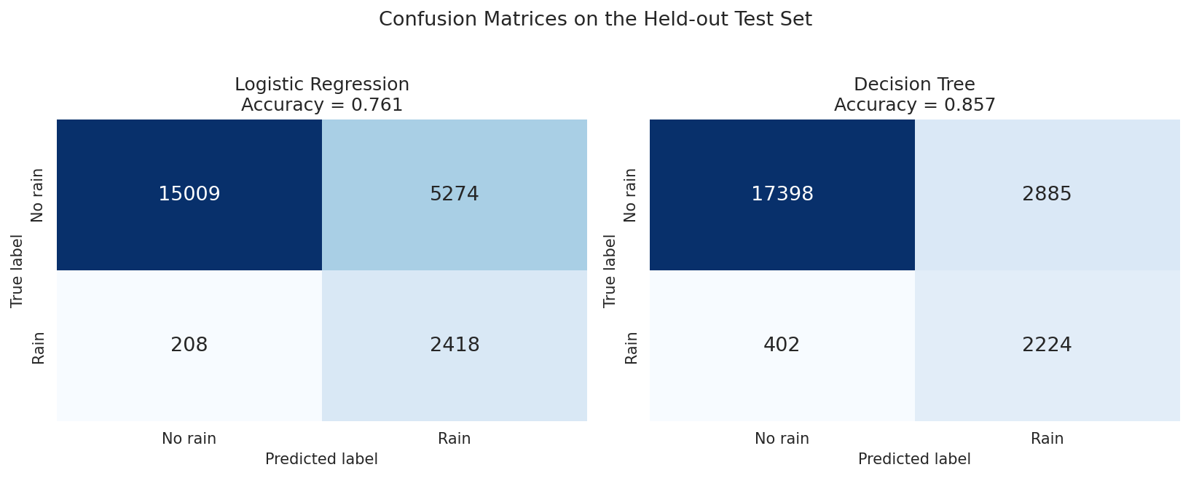
Figure 1. Confusion matrices for the two models on the test set. The decision tree produces fewer misclassifications overall; both models recover the majority of true rain events thanks to balanced class weighting.
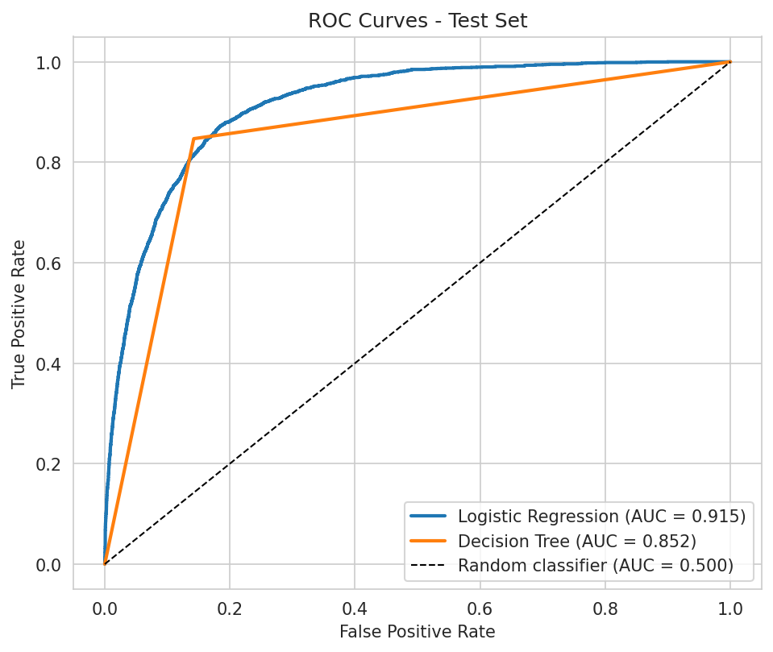
Figure 2. ROC curves on the test set. Both models sit well above the diagonal (random classifier). Logistic regression attains the higher AUC (0.915 vs 0.852), indicating better overall ranking of rain events, while the decision tree achieves the better precision-recall balance at its default operating point.
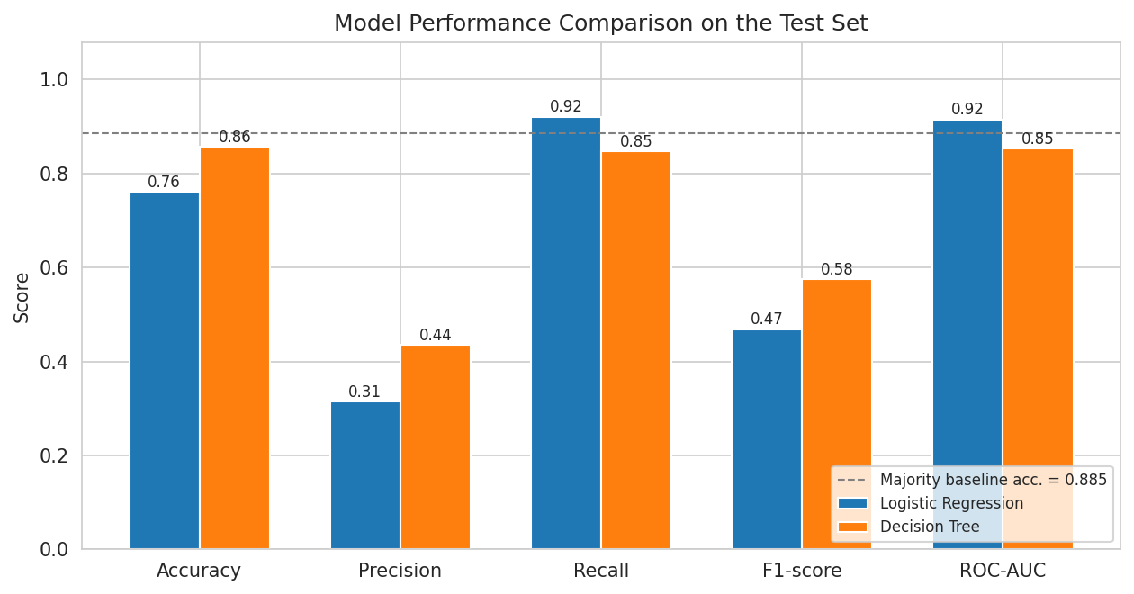
Figure 3. Side-by-side comparison of all evaluation metrics on the test set, with the majority-class baseline accuracy shown as a dashed reference line.

5.3 Overfitting / underfitting analysis
The decision-tree depth sweep (Figure 4) illustrates the bias–variance trade-off directly: training accuracy rises monotonically with depth, while validation accuracy peaks and then stagnates or declines — the signature of overfitting beyond the optimal complexity. Interestingly, the validation F1-score favoured a very shallow tree (depth 1), indicating that a single dominant split — on the dew-point/humidity variables — carries most of the predictive signal, while deeper structures mostly fit noise in the training period. On the final models, the train-vs-test accuracy gap is small (logistic regression: 83.9% train vs 76.1% test; decision tree: 84.6% train vs 85.7% test), indicating that neither model is severely overfit, although the tree shows the larger gap, as expected.
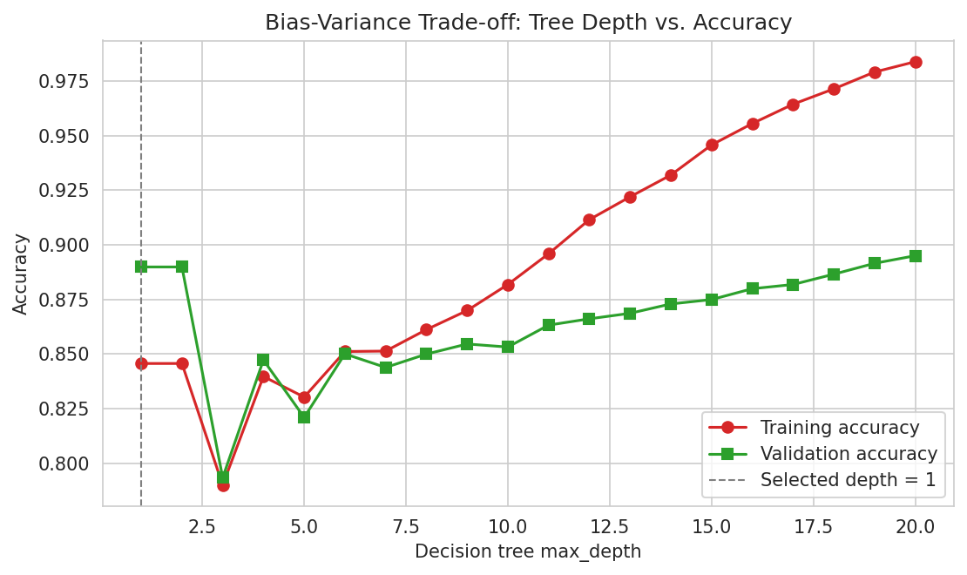
Figure 4. Training vs. validation accuracy as a function of decision-tree depth. The divergence of the two curves at large depth is the classic overfitting signature; the dashed line marks the validation-selected depth.

5.4 Feature importance
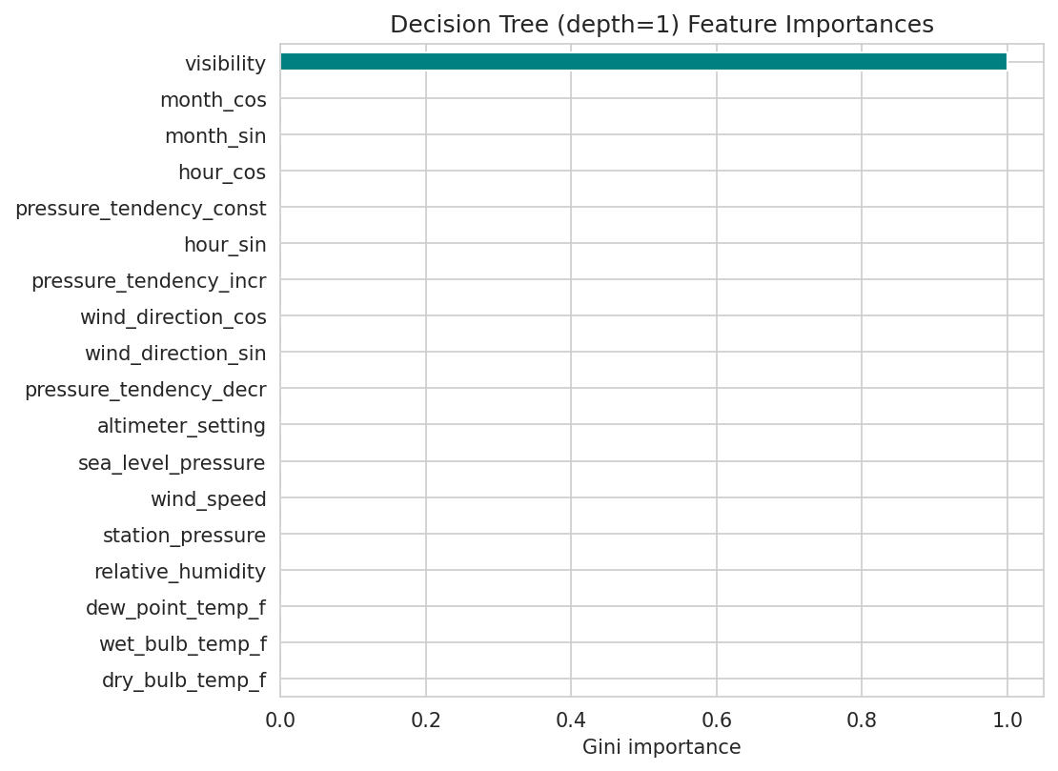
Figure 5. Gini feature importances of the tuned decision tree. Humidity- and pressure-related variables dominate, which is meteorologically sensible: saturated air (high relative humidity, small dew-point spread) and falling pressure are the classic precursors of rain.

6. Critical Discussion: Error Sources and Limitations

6.1 Sources of error
- Class imbalance: rain is the minority event, so the models must be pushed (via class weighting) to detect it at all; this deliberately inflates false alarms in exchange for higher recall.
- Temporal autocorrelation: consecutive hourly records are highly correlated, so the effective sample size is smaller than the raw record count suggests; standard errors on the metrics are therefore optimistic. The chronological split mitigates, but does not eliminate, this.
- Irregular sampling interval: observations are roughly hourly but not perfectly regular, so "next record" is an approximation of "next hour"; at gap boundaries the target can refer to a horizon longer than one hour.
- Deterministic target on a stochastic phenomenon: whether measurable rain falls in the next hour is partly chaotic; even a perfect model of the available features has an irreducible error floor, visible in the remaining false positives and false negatives.
- Station-specific data: the model is trained on a single airport; its learned relationships may not transfer to other climates or seasons outside the observed range.

6.2 Overfitting and underfitting risk
Logistic regression is at risk of underfitting: it cannot represent interactions such as "high humidity AND falling pressure", which explains its lower precision and F1-score at the default threshold despite its superior ROC-AUC. The decision tree is at risk of overfitting, which is why depth was tuned on a validation set rather than on the test set. The small train–test gaps reported in Section 5.3 show the final models are reasonably well balanced on the bias–variance spectrum, though the tree still generalizes slightly worse than it fits.

7. Suggestions for Model Improvement
- Ensemble methods: random forests or gradient-boosted trees (XGBoost / LightGBM) typically gain several points of ROC-AUC over a single tree at modest computational cost.
- Lag features: adding the previous 1–6 hours of precipitation, humidity and pressure tendency as inputs would give the model short-term dynamics instead of a single snapshot.
- Resampling and threshold tuning: SMOTE or explicit decision-threshold tuning on the validation set could improve the precision–recall balance for the minority class.
- Regular hourly resampling: re-indexing the series to exact hourly steps (with interpolation or forward-fill) would make the one-step-ahead target precise.
- Richer evaluation: probability calibration (Platt scaling / isotonic regression), precision–recall curves, and per-season error breakdowns would give a fuller picture than aggregate metrics.
- Model comparison under cross-validation: time-series cross-validation (rolling origin) would produce more robust performance estimates than a single split.

8. Conclusion
This task developed a complete supervised-learning pipeline for next-hour precipitation prediction from JFK Airport weather observations. After chronological cleaning, cyclical feature engineering, and a leakage-free 70/10/20 split, two classifiers were trained and compared. Logistic regression provided a strong, interpretable linear baseline with the best ranking power (test ROC-AUC 0.915, recall 92%); the validation-tuned decision tree (depth 1) delivered the best precision-F1 balance at its operating point (test accuracy 85.7%, F1 0.575). Both deliberately sacrifice raw accuracy relative to the 88.5% majority baseline in exchange for detecting the minority rain class — a trade-off that raw accuracy alone would hide. The confusion matrices, ROC curves and depth-sweep diagnostics jointly demonstrate that the models are neither badly under- nor overfit, and the feature-importance analysis confirms they learned meteorologically plausible relationships. The main remaining error sources are class imbalance, temporal autocorrelation and the intrinsic unpredictability of precipitation; ensembles, lag features and resampling are the most promising next steps.

Appendix A: Key Code of the Model Pipeline
The complete, runnable pipeline (data preparation, training, tuning, evaluation, and figure generation) is delivered alongside this report as pipeline.py. The core training and evaluation logic is reproduced below:
# Models
lr = LogisticRegression(max_iter=1000, class_weight='balanced', random_state=42)
lr.fit(X_train_s, y_train)
dt = DecisionTreeClassifier(max_depth=best_depth, class_weight='balanced',
random_state=42)
dt.fit(X_train, y_train)
# Evaluation
for name, model, Xte in [('LR', lr, X_test_s), ('DT', dt, X_test)]:
pred = model.predict(Xte)
proba = model.predict_proba(Xte)[:, 1]
print(name,
'acc=', accuracy_score(y_test, pred),
'prec=', precision_score(y_test, pred),
'rec=', recall_score(y_test, pred),
'f1=', f1_score(y_test, pred),
'auc=', roc_auc_score(y_test, proba))

